System Usability Scale

# Name: Task: Date:

1. I think that I would like to use this system frequently.

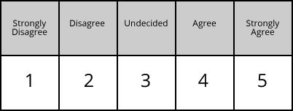

1. I found the system unnecessarily complex.



1. I thought the system was easy to use.



1. I think that I would need the support of a technical person to be able to use this system.



1. I found the various functions in this system were well integrated.



1. I thought there was too much inconsistency in this system.
2. I would imagine that most people would learn to use this system very quickly.



1. I found the system very cumbersome to use.
2. I felt very confident using the system.



1. I needed to learn a lot of things before I could get going with this system.